Pre-Module Activity: Introduction to Git, GitHub, and VSCode

This pre-module activity is designed to help you set up your development environment, learn the basics of Git and GitHub, and refresh your JavaScript skills from beginner to advanced concepts. By the end of this activity, you will:

1. Set up Visual Studio Code (VSCode) as your IDE.
2. Create a GitHub account and learn how to use it for version control.
3. Practice basic Git commands (init, add, commit, push, pull).
4. ~~Build a small JavaScript project to review key concepts, from basics to advanced topics.~~

Step 1: Set Up Your Development Environment

1. **Install Visual Studio Code (VSCode):**

* Download and install VSCode from <https://code.visualstudio.com/>.
* Install the following extensions for a better development experience:
  + 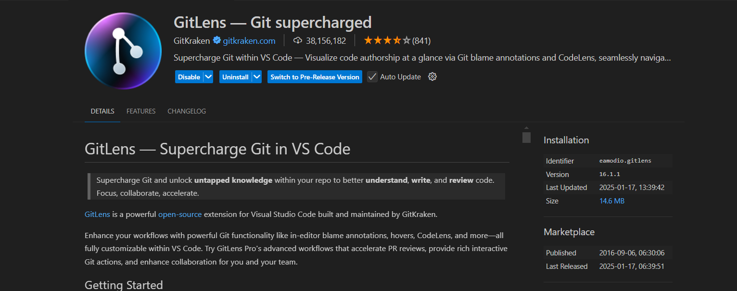**GitLens**: Enhances Git capabilities in VSCode.
  + 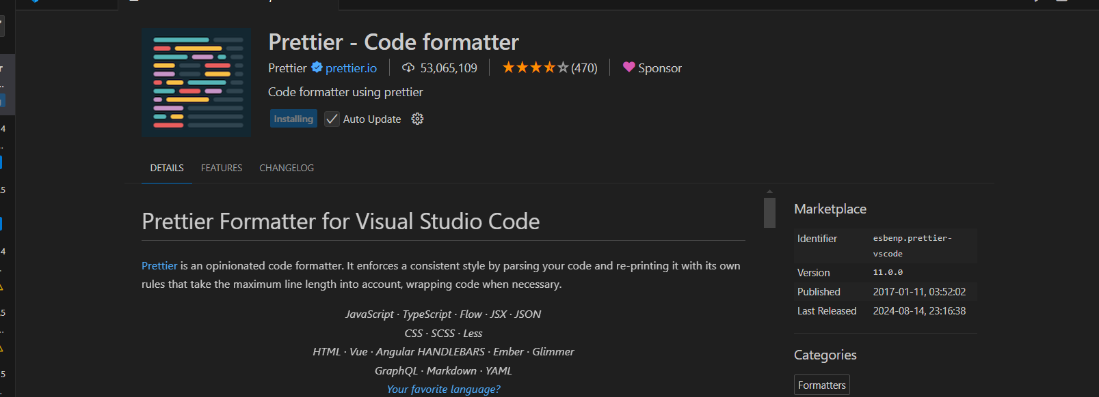**Prettier**: Automatically formats your code.
  + 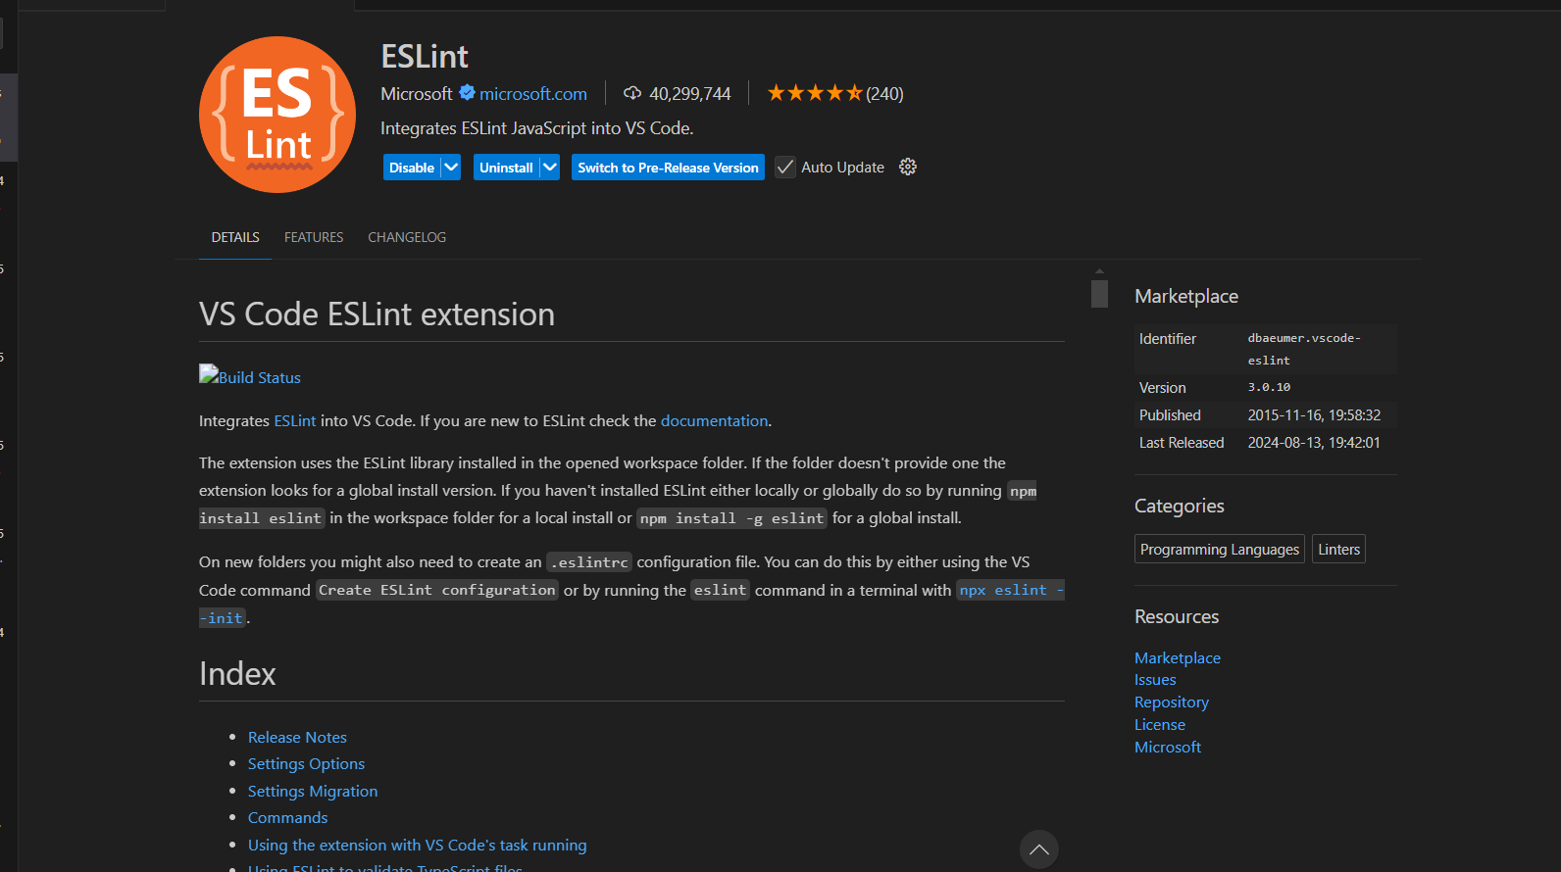**ESLint**: Helps identify and fix JavaScript errors.

1. **Install Git:**

* Download and install Git from <https://git-scm.com/>.
* Verify the installation by running the following command in your terminal:

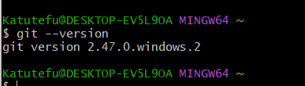

1. **Create a GitHub Account:**

* 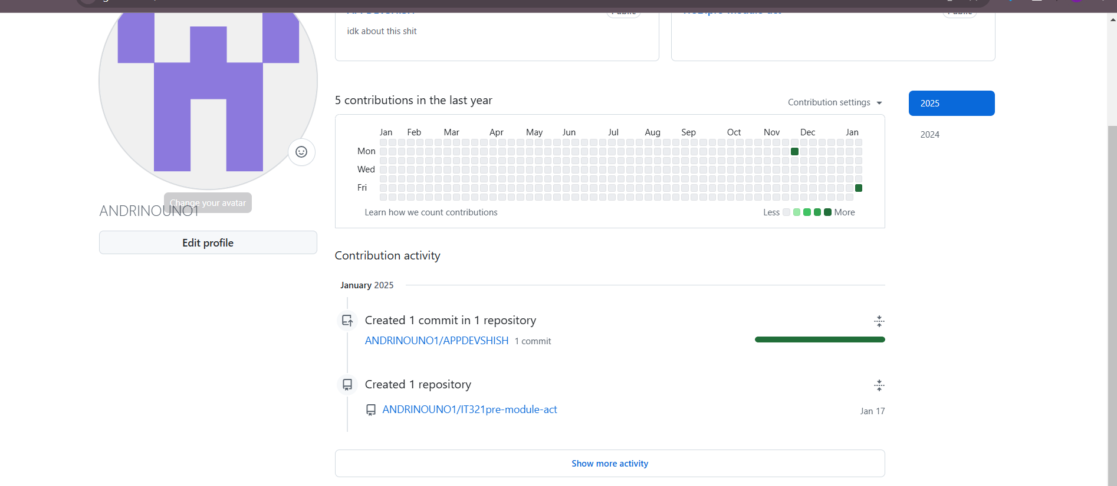Sign up for a free account at <https://github.com/>

# Step 2: Learn Basic Git Commands

1. **Initialize a Local Git Repository:**

* Open VSCode and create a new folder for your project (e.g., js-review-project).
* 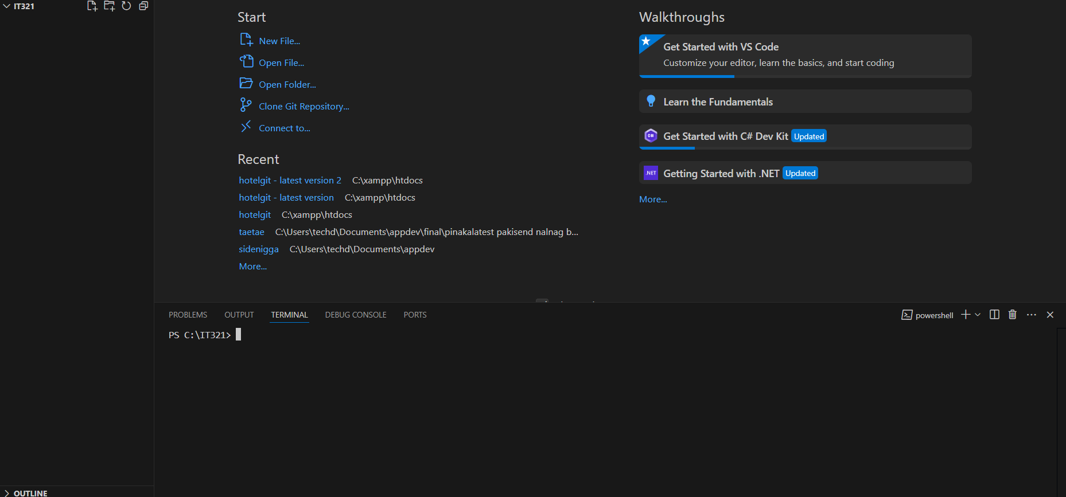Navigate to your project folder.

* Initialize a Git repository:

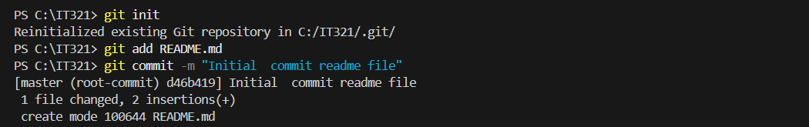

1. **Create a README.md File:**

* Add a README.md file to describe your project:

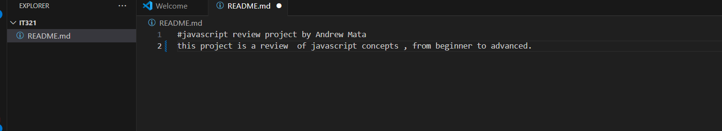

**3.Stage and Commit Changes:**

* Stage the README.md file:



* Commit the changes:

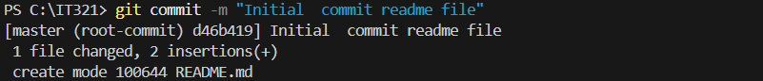

**4.Link to GitHub:**

* Create a new repository on GitHub (e.g., js-review-project).
* Link your local repository to GitHub:

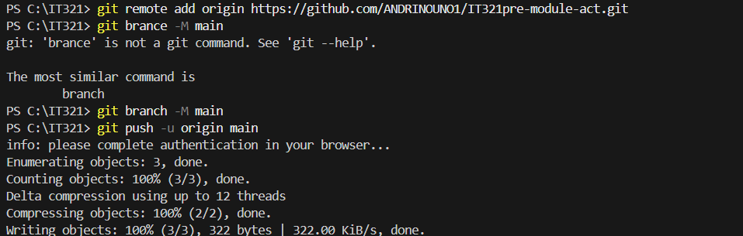

Refresh project on github

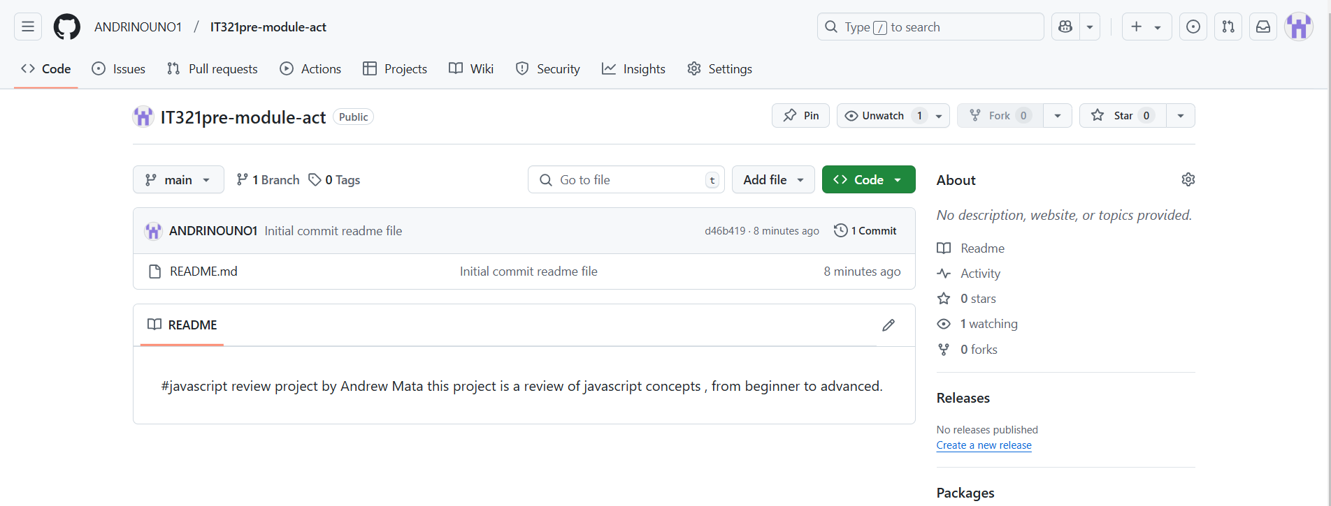

**5.Practice Git Workflows:**

* Make changes to your project (e.g., add a new file or update the README.md).

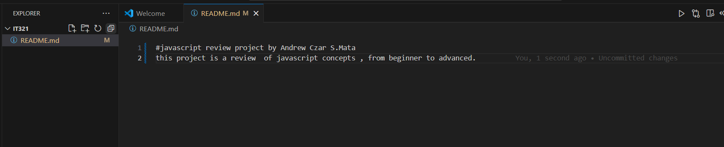

* Stage, commit, and push the changes:

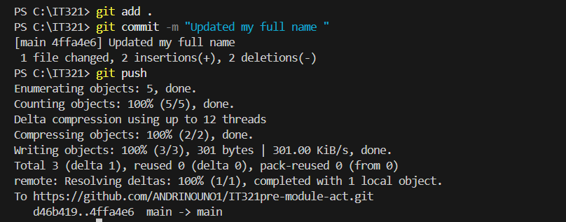

* Check github repo

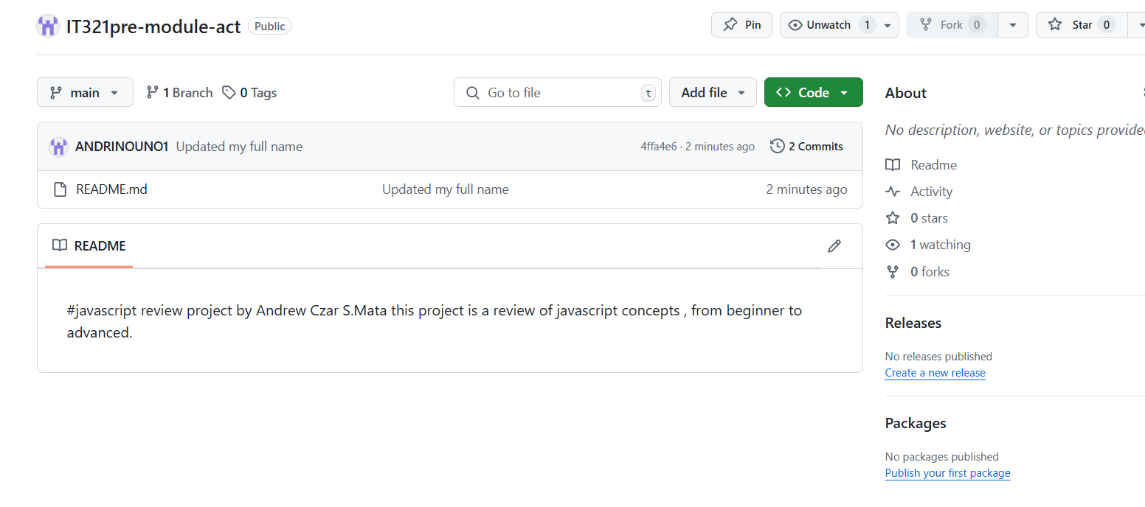

* Updating github repo and pull changes from GitHub to your local repository:

